Final Project Report

UNIVERSITY ANALYTICS SYSTEM



PREPARED BY:
ASSOCIATE ID | ASSOCIATE NAME
2387349 | Drisshya S

GUIDED BY:
Mentor & Trainer Coach
Kavin Kumar G Akash Nair
Associate CPO L&D GenC Training
AIA - Cloud Data Integration Contractor – GenC

CONTENTS

- Introduction
- Purpose and Scope of the Project
- Aim of the Project
- Architecture Diagram
- Flowchart
- Functional Requirement 1: Student Dimension
- Functional Requirement 2: College Dimension
- Functional Requirement 3: Faculty Dimension
- Functional Requirement 4: Department Dimension
- Functional Requirement 5: Course Dimension
- Functional Requirement 6: Time Dimension
- Functional Requirement 7: Result Staging
- Functional Requirement 8: Result Fact
- Functional Requirement 9: Result Aggregate
- Integrated Taskflow
- Design Constraints
- Conclusion

ABBREVIATIONS

TERM | DESCRIPTION
ETL | Extraction, Transformation and Loading / Extract, Transform and Load
SRC | Source
TGT | Target
SQ | Source Qualifier
WF | Workflow
EXP | Expression
SEQ | Sequence Generator
LKP | Lookup
AGG | Aggregator
FIL | Filter
RTR | Router
SRT | Sorter
UN | Union
JNR | Joiner

TABLES
Table 1: Student Dimension Source Description
Table 2: Student Target Description
Table 3: Student Dimension Transformations
Table 4: College Dimension Source Description
Table 5: College Target Description
Table 6: College Dimension Transformations
Table 7: Faculty Dimension Source Description
Table 8: Faculty Target Description
Table 9: Faculty Dimension Transformations
Table 10: Department Dimension Source Description
Table 11: Department Target Description
Table 12: Department Transformations
Table 13: Course Dimension Source Description
Table 14: Course Target Description
Table 15: Course Transformations
Table 16: Time Dimension Source Description
Table 17: Time Target Description
Table 18: Time Transformations
Table 19: Result Staging Dimension Source Description
Table 20: Result Staging Target Description
Table 21: Result Staging Transformations
Table 22: Result Fact Dimension Source Description
Table 23: Result Fact Target Description
Table 24: Result Fact Transformations
Table 25: Result Aggregate Student Dimension Source Description
Table 26: Result Aggregate Target Description
Table 27: Result Aggregate Transformations
Table 28: Design Constraints

FIGURES

Fig. 1: System Flow Diagram
Fig. 2: Architecture Diagram
Fig. 3: Flow Chart
Fig. 4: Student Mapping
Fig. 5: Student Dimension Mapping Task
Fig. 6: Student Dimension Monitor
Fig. 7: Student Dimension Target Table
Fig. 8: College Mapping
Fig. 9: College Dimension Mapping Task
Fig. 10: College Dimension Monitor
Fig. 11: College Dimension Target Table
Fig. 12: Faculty Mapping
Fig. 13: Faculty Dimension Mapping Task
Fig. 14: Faculty Dimension Monitor
Fig. 15: Faculty Dimension Target Table
Fig. 16: Department Mapping
Fig. 17: Department Dimension Mapping Task
Fig. 18: Department Dimension Monitor
Fig. 19: Department Dimension Target Table
Fig. 20: Course Target Definition
Fig. 21: Course Mapping
Fig. 22: Course Dimension Mapping Task
Fig. 23: Course Dimension Monitor
Fig. 24: Time Mapping
Fig. 25: Time Dimension Mapping Task
Fig. 26: Time Dimension Monitor
Fig. 27: Time Dimension Target Table
Fig. 28: Staging Mapping
Fig. 29: Staging Mapping Task
Fig. 30: Staging Result Monitor
Fig. 31: Staging Result Target Table
Fig. 32: Staging Error Target Table
Fig. 33: Result Fact Mapping
Fig. 34: Result Fact Mapping Task
Fig. 35: Result Fact Monitor
Fig. 36: Result Fact Target Table
Fig. 37: Result Aggregate Mapping
Fig. 38: Result Aggregate Mapping Task
Fig. 39: Result Aggregate Monitor
Fig. 40: Result Aggregate Target Table
Fig. 41: Integrated Taskflow
Fig. 42: Integrated Taskflow Notification

Introduction
The project titled University Analytics System aims to streamline and enhance the management of academic data within a university setting. This system focuses on aggregating data from multiple supporting dimension tables to generate a comprehensive Result table, which provides a unified view of critical information. By integrating data from various dimensions such as Student, Department, Time, Faculty, Course, and College, the system ensures efficient data handling and analysis, enabling informed decision-making and improved institutional management.

The dimension tables serve specific purposes: the Student table holds individual student records, while the Department table captures details of departments within the college. The Time dimension table organizes examination schedules, and the Faculty table stores faculty-related information. Similarly, the Course table maintains course-related data, and the College table provides an overview of college attributes, including its location, code, and name. Together, these tables form a robust foundation for data analytics, supporting a seamless flow of information and enabling the generation of accurate and actionable insights.

This project is significant as it addresses the need for a centralized analytical system in academic institutions, ensuring data consistency, accessibility, and enhanced decision-making capabilities. The introduction outlines the scope and structure of the project, highlighting its contribution to improving operational efficiency and educational outcomes.

Purpose and Scope of the Project
The primary purpose of the University Analytics System project is to develop an efficient and centralized system for managing and analyzing academic data within a university setting. By aggregating data from various dimension tables—such as Student, Department, Time, Faculty, Course, and College—the system aims to provide accurate and actionable insights that support decision-making and improve institutional operations. This project seeks to enhance the accessibility, consistency, and usability of academic data for administrators, faculty, and other stakeholders within the university.

The scope of this project encompasses the design and development of a Result table that integrates data from all supporting dimension tables, ensuring a comprehensive view of institutional analytics. This includes capturing and managing data related to students, departments, examinations, faculty, courses, and colleges, which collectively form the foundation for effective data analysis. The project is intended to serve as a robust analytics system that addresses business needs and operational challenges faced by universities, enabling data-driven decision-making and facilitating strategic improvements in academic and administrative processes.
Aim of the Project
The aim of the University Analytics System project is to create a centralized and efficient platform for managing and analyzing academic data across various dimensions within a university. The system seeks to generate a comprehensive Result table by aggregating data from supporting dimension tables, including Student, Department, Time, Faculty, Course, and College. By integrating these data sources, the project aims to provide accurate insights that support informed decision-making, improve institutional operations, and enhance the overall management of academic and administrative processes.

This project is designed to empower universities with a robust analytical framework, facilitating data-driven decisions that promote strategic improvements and operational excellence in the academic environment

Modules present in the project
- Student dimension
- College dimension
- Time dimension
- Department dimension
- Course dimension
- Faculty dimension
- Result Staging
- Result fact
- Result Aggregate

System diagram
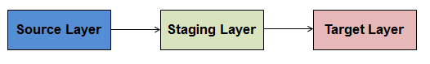
Fig.1: System Flow diagram

The system follows a structured data flow model comprising three key stages: Source, Staging, and Target. In the Source stage, raw data is collected from various input tables such as Student, Department, Faculty, and others. This data is then transferred to the Staging area, where it undergoes processing, transformation, and validation to ensure consistency and accuracy. Finally, the refined data is moved to the Target stage, where it is consolidated into the Result table, enabling comprehensive analysis and decision-making. This streamlined approach ensures efficient data integration and management across the system.

Architecture Diagram
The Logical Architecture defines the Processes (the activities and functions) that are required to provide the required User Services. Many different Processes must work together and share information to provide a User Service. The processes can be implemented via software, hardware, or firmware. Logical Architecture is independent of technologies and implementations.
University Analytics system has 6-dimensional table, 1 staging table and 1 fact table.

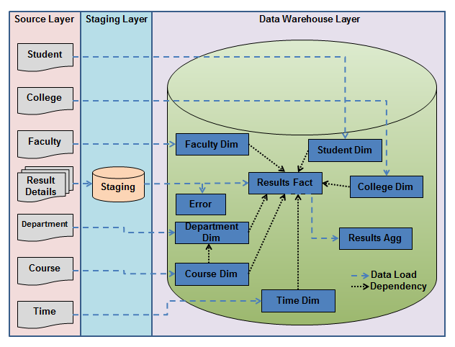
Fig. 2: Architecture Diagram

Flow Chart

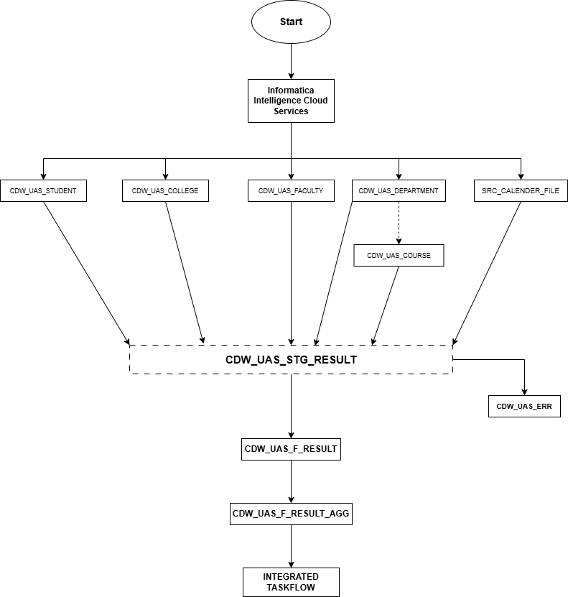

Stop

Fig. 3: Flow Chart

Functional Requirement 1

STUDENT
The Student dimension table CDW_UAS_D_STUDENT is a Type – II SCD table which contains all students’ information. The source file’s name is CDW_UAS_STUDENT.txt. The source file is a comma (,) delimited file. The source sends the file on a daily basis. History of the students’ needs to be maintained in the table.

SOURCE
The source files provided in the requirement document is a comma separated file described in the table containing the following attributes like FIRST_NAME, MIDDLE_NAME, LAST_NAME, ROLL, STREET_NAME, APT_NO, STUD_CITY, STUD_STATE, STUD_COUNTRY, STUD_ZIP, STUD_PHONE and STUD_EMAIL. The source is imported to mapping task by creating a connection to flat file provided the location of the file as shown in fig .

SOURCE FILE NAME | DESCRIPTION | SOURCE FILE
CDW_UAS_D_STUDENT.txt | This is a delimited file (comma) with 12 input fields. | 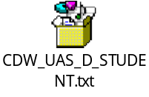
Table 1: CDW_UAS_D_STUDENT Source Description

TARGET
The target table is created in the SQL server database where the attributes are selected from the provided requirements document and imported to the Informatica mapping data integration. The output table description is explained in the table. The target database need to maintain unlimited history [SCD-2] with date flag.

TARGET NAME | DESCRIPTION | TARGET TYPE | TARGET FILE
CDW_UAS_D_STUDENT | It is an SQL server database table maintaining the required information. | SQL server Database | 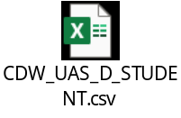
Table 2: CDW_UAS_D_STUDENT Target Description

TRANSFORMATIONS:
Column Name | Mapping Logic | Transformation Name | Function Used
STUD_ID | System generated based on Student SSN.  Insert for new Student/ expire the old record and  insert the updated record for existing Students | Sequence Generator
STUD_F_NAME | Convert the Name to Title Case | Expression | InitCap()
STUD_M_NAME | Convert the middle name in lower case | Expression | Lower()
STUD_L_NAME | Convert the Last Name in Title Case | Expression | InitCap()
STUD_ROLLNO | Direct move ( Abort the session if Roll Number is invalid. Convert to number ) | Expression | IIF()
STUD_STREET | Concatenate Apartment no and Street name of Student's Residence with comma as a separator . | Expression | IIF()
STUD_CITY | Direct Move |  | Concat()
STUD_STATE | Direct Move
STUD_COUNTRY | Direct move
STUD_ZIP | Direct move ( Convert to number )
STUD_PHONE | Change the format to xxx-xxx-xxxx |  | ToInteger()
STUD_EMAIL | Direct move |  | Substr()
CREATED_DATE | SYSDATE
END_DATE | Null on insert / SYSDATE - (1Sec) on update. |  | SYSDATE
Table 3: CDW_UAS_D_STUDENT Transformations

MAPPING
The figure below illustrates the data flow from the source to the target table, applying the necessary transformations to meet the business requirements.
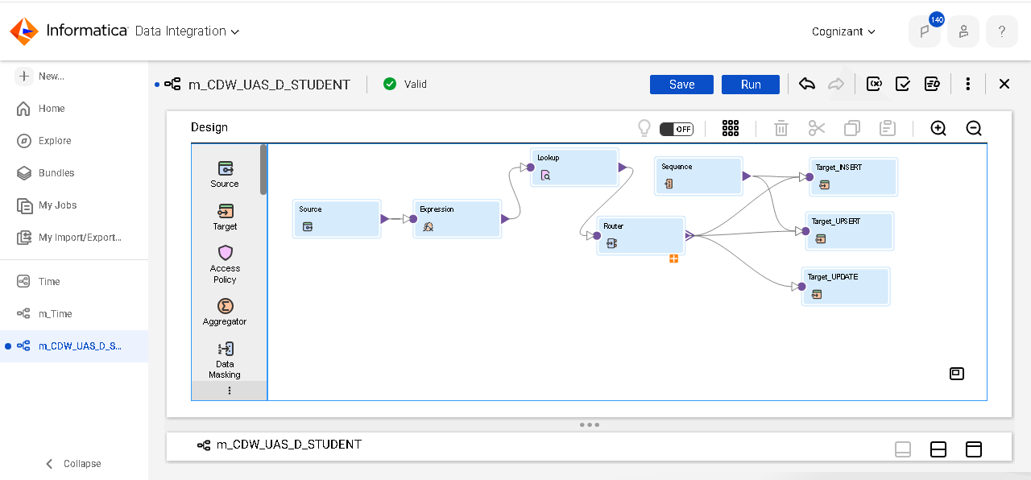
Fig. 4: Student Dimension Mapping

Mapping Task
The figure below illustrates the Mapping task that executes the mappings created in the data integration service of IICS. This mapping task ensures that the data is extracted from the source files, transformed according to the specified business logic and loaded into the target table.
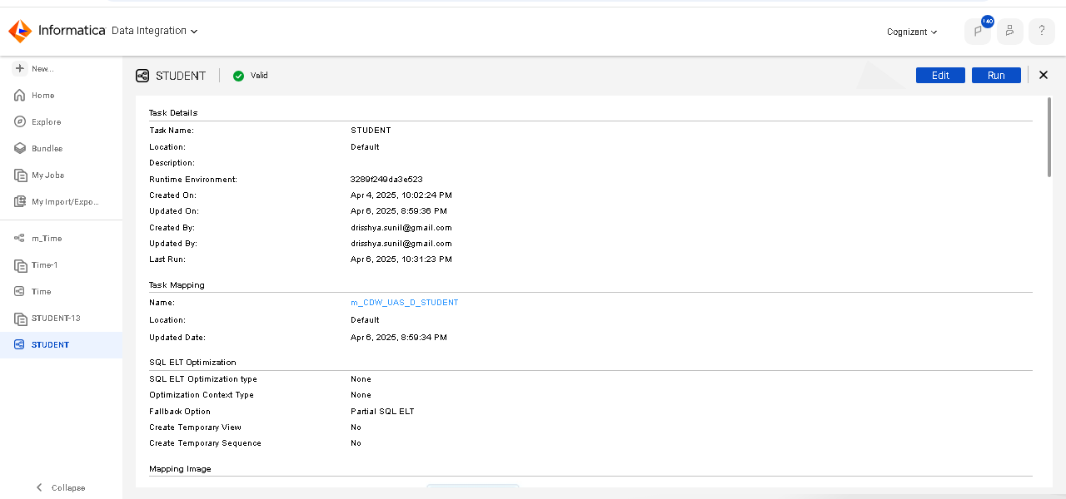
Fig. 5: Student Dimension Mapping Task

MONITOR DETAILS:
The monitor gives the task status, and the number of rows accepted is also verified. The target table STUDENT_UAS is verified in the SQL server database as shown in the figure.
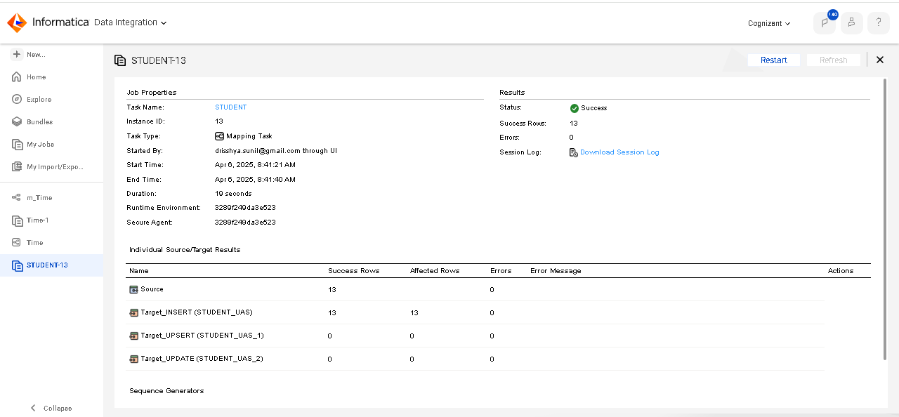
Fig. 6: Student Dimension Monitor

TARGET POST EXECUTION:
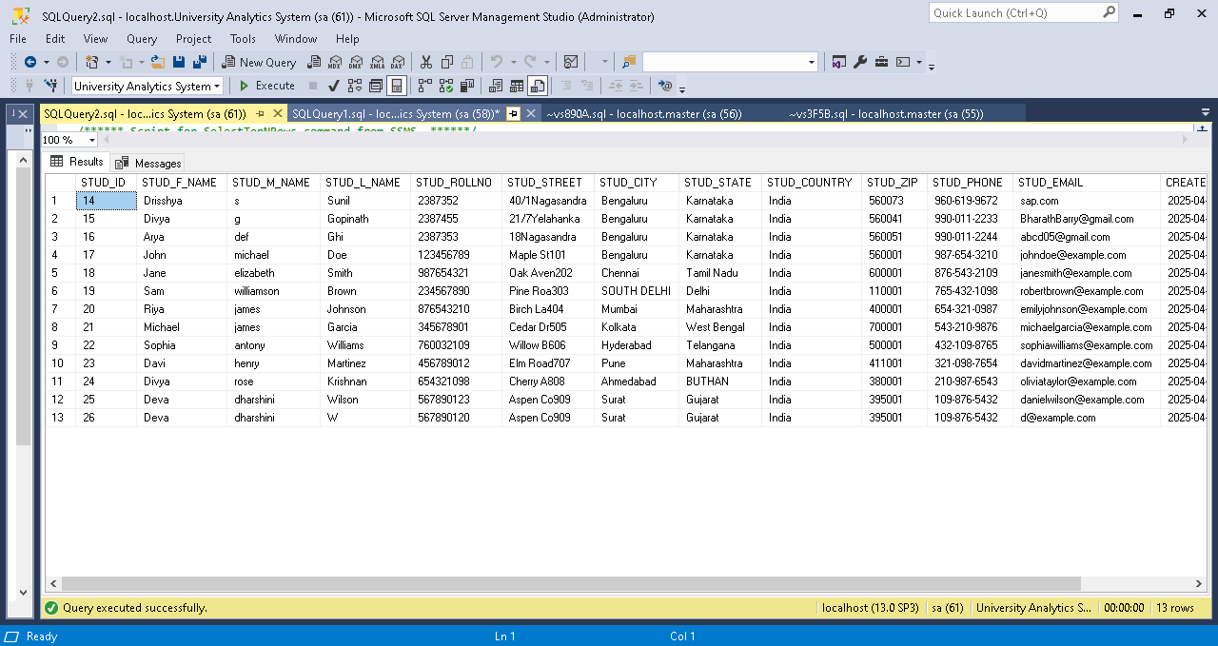
Fig. 7: Student Dimension Target Table

Functional Requirement 2

COLLEGE
The College dimension table CDW_UAS_D_COLLEGE is a Type – I SCD which contains all college details. Data is added to this table, only when a new college is being opened. So, the load schedule would be on demand. The source file’s name is CDW_UAS_COLLEGE.txt and it is pipe (|) delimited. The table is updated/ inserted for old/ new branches respectively and no history is maintained.

SOURCE
The source files provided in the requirement document are a text file described in the table containing the following attributes like COLLEGE_CODE, COLLEGE_NAME, COLLEGE_STREET, COLLEGE_CITY, COLLEGE_STATE, COLLEGE_ZIP and COLLEGE_PHONE. The source is imported to the source analyser as shown in fig .

SOURCE FILE NAME | DESCRIPTION | SOURCE FILE
CDW_UAS_D_COLLEGE (flat file) | This is a pipeline separated file. | 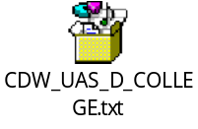
Table 4: CDW_UAS_D_COLLEGE Source Description

TARGET
The target table is created in the SQL server database where the attributes are selected from the provided requirements document and imported to the Informatica mapping data integration service.

TARGET NAME | DESCRIPTION | TARGET TYPE | TARGET FILE
CDW_UAS_D_COLLEGE | It is an SQL server database table maintaining the required information. | SQL server Database | 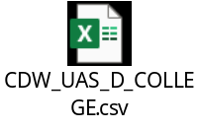
Table 5: CDW_UAS_D_COLLEGE Target Description

TRANSFORMATIONS:

Column Name | Mapping Logic | Transformation Name | Function Used
COLLEGE_CODE | Insert if new College/update the entire record for existing College
COLLEGE_NAME | Direct move
COLLEGE_STREET | Direct move
COLLEGE_CITY | Direct move
COLLEGE_STATE | Direct move
COLLEGE_ZIP | If the source value is null load default value else Direct move |  | IIF()
COLLEGE_PHONE | Change the format of phone number to (XXX)XXX-XXXX |  | SUBSTR()  Concat()
Table 6: CDW_UAS_D_COLLEGE Transformations
MAPPING
The figure below illustrates the data flow from the source to the target table, applying the necessary transformations to meet the business requirements.

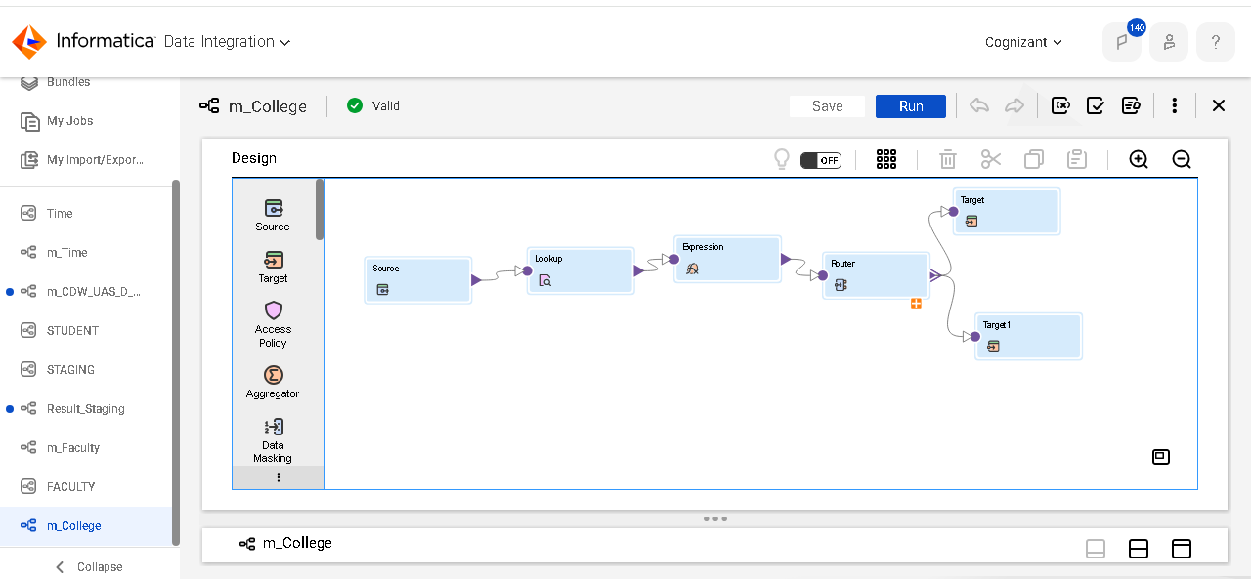
Fig. 8: College Dimension Mapping

MAPPING TASK
The figure below illustrates the mapping task that executes the mappings created in the mappings. This mapping task ensures that the data is extracted from the source files, transformed according to the specified business logic, and loaded into the target tables.

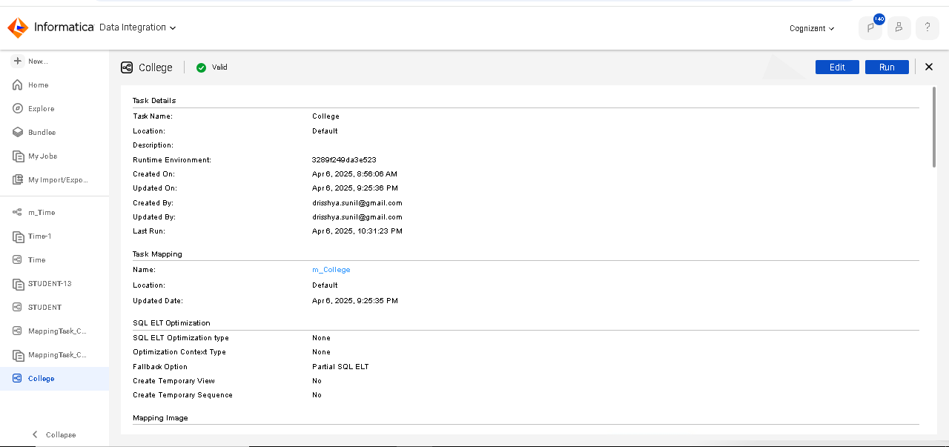
Fig. 9: College Dimension Mapping Task

MONITOR DETAILS:
The monitor gives the task status, and the number of rows accepted is also verified. The data sent to the target file CDW_UAS_D_COLLEGE is verified in the SQL server database as shown in the figure.

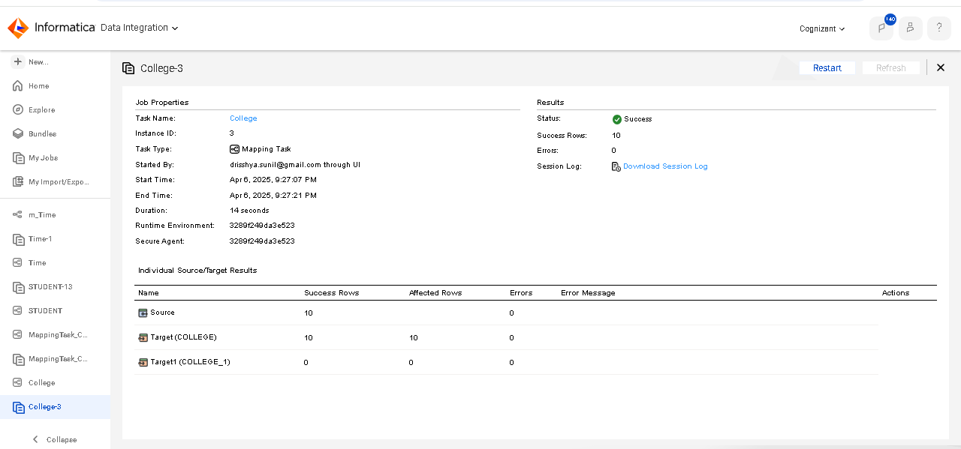
Fig. 10: College Dimension Monitor

TARGET POST EXECUTION:
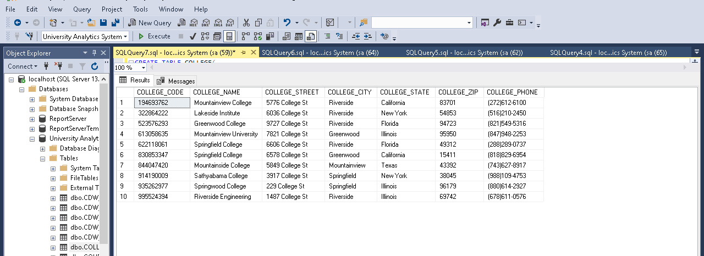
Fig. 11: College Dimension Target Table

Functional Requirement 3

FACULTY
The faculty dimension table CDW_UAS_D_FACULTY is a Type – I SCD which contains all faculty details. The source file’s name is CDW_UAS_D_FACULTY.txt and it is comma (,) delimited. The table is updated/ inserted for old/ new branches respectively and no history is maintained.

SOURCE
As per the requirement, we have been provided with a source comma-separated file. The source file contains field such as a FACULTY_CODE, FACULTY_NAME, FACULTY_DESIGNATION and FACULTY_QUALIFICATION.

SOURCE FILE NAME | DESCRIPTION | SOURCE FILE
CDW_UAS_D_FACULTY.txt (flat file) | This is a comma-separated file. | 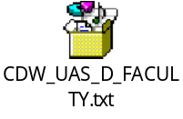
Table 7: CDW_UAS_FACULTY Source Description
TARGET
The target table is created in the SQL server database where the attributes are selected from the provided requirements document and imported to the Informatica.
TARGET NAME | DESCRIPTION | TARGET TYPE | TARGET FILE
CDW_UAS_D_FACULTY | It is a SCD type 1 table | SQL Server Database | 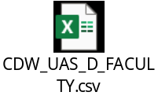
Table 8: CDW_UAS_D_FACULTY Target Description

TRANSFORMATIONS:
Column Name | Mapping Logic | Transformation Name | Function Used
FACULTY_CODE | Insert if new College/update the entire record for existing College
FACULTY_NAME | Direct move
FACULTY_DESIGNATION | Direct move
FACULTY_QUALIFICATION | Direct move
Table 9: CDW_UAS_D_FACULTY Transformations

MAPPING
The figure below illustrates the data flow from the source to the target table, applying the necessary transformations to meet the business requirements.
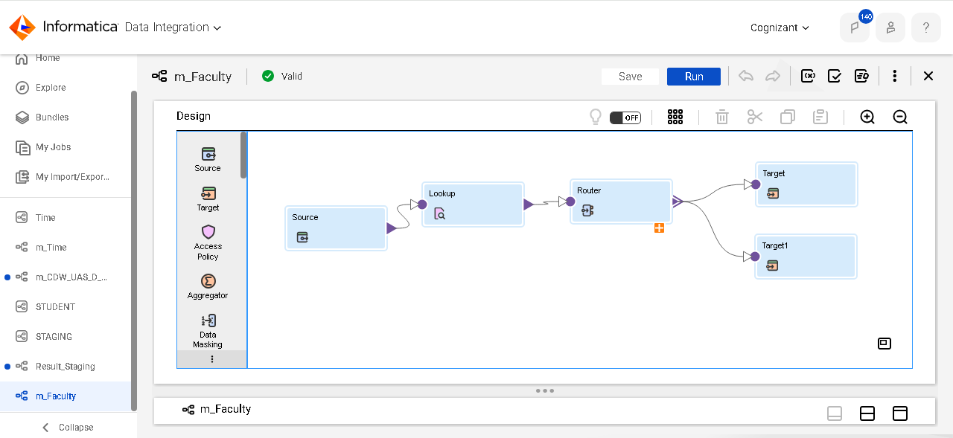
Fig. 12: Faculty Dimension Mapping

MAPPING TASK
The figure below illustrates the mapping task that executes the mappings created in the Informatica. This mapping task ensures that the data is extracted from the source files, transformed according to the specified business logic and loaded into the target tables.

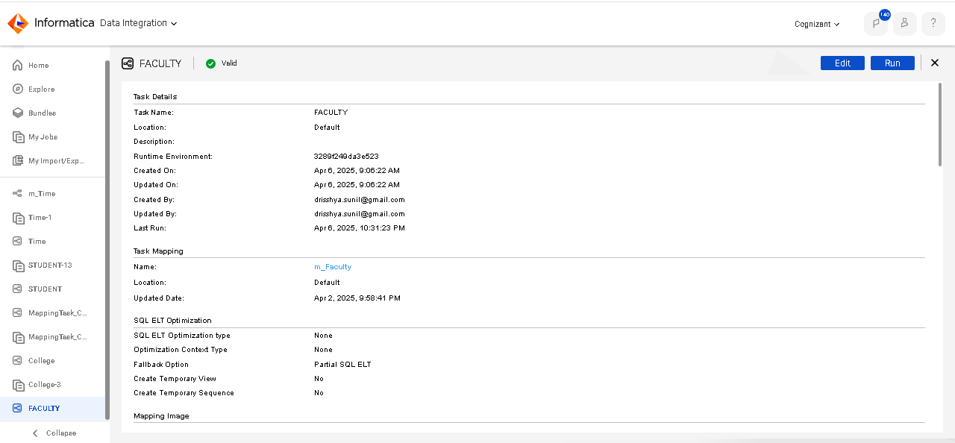
Fig. 13: Faculty Dimension Mapping Task

MONITOR DETAILS:
The monitor gives the task status, and the number of rows accepted is also verified. The data IN the target file CDW_UAS_D_FACULTY is verified in the SQL server database as shown in the figure.

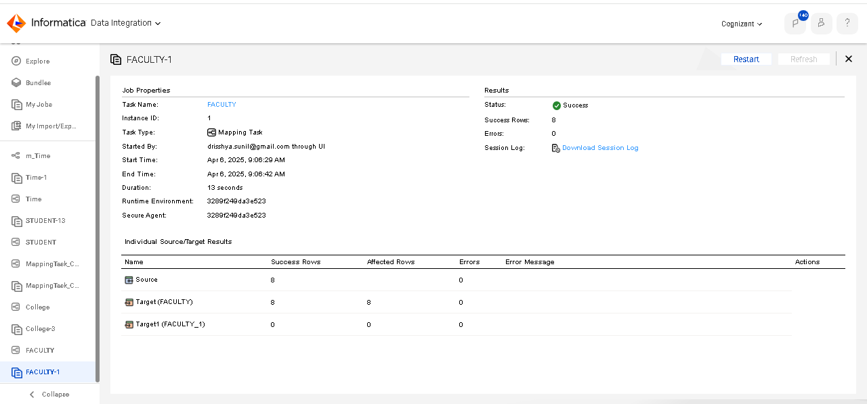
Fig. 14: Faculty Dimension Monitor

TARGET POST EXECUTION:

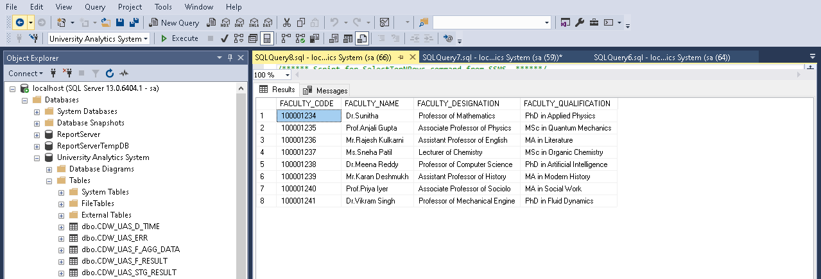
Fig. 15: Faculty Dimension Target Table

Functional Requirement 4

DEPARTMENT
The Department dimension table CDW_UAS_D_DEPARTMENT is a Type – I SCD table which contains all the departments’ information. The source file’s name is CDW_UAS_DEPARTMENT.txt and it is pipe (|) delimited. The table is updated/inserted for old/new suppliers respectively on a daily basis and no history is maintained.

SOURCE
As per the requirement, we have been provided with a source comma-separated file. The source file contains field such as a DEPARTMENT_NAME, DEPARTMENT_NO, DEPARTMENT_PHONE and DEPARTMENT_HOD.

SOURCE FILE NAME | DESCRIPTION | SOURCE FILE
CDW_UAS_DEPARTMENT.txt | This is an fixed file (pipeline separated) file. | 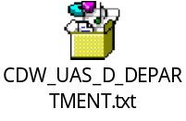
Table 10: CDW_UAS_D_DEPARTMENT source
TARGET
The target table is created in the SQL server database where the attributes are selected from the provided requirements document and imported to the Informatica.
TARGET NAME | DESCRIPTION | TARGET TYPE | TARGET FILE
CDW_UAS_D_DEPARTMENT | It is a SCD type 1 table | SQL Server Database | 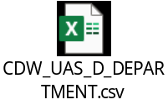
Table 11: CDW_UAS_D_DEPARTMENT Target Description

TRANSFORMATIONS:

Column Name | Mapping Logic | Transformation Name
DEPARTMENT_ID | System generated based on Department No. Insert for new Department/update the entire record for existing Departments.
DEPARTMENT_NAME | If a percentage symbol is present in the name of Department remove and load else direct move
DEPARTMENT_NO | Direct move (Abort the session if Number is invalid)
DEPARTMENT_PHONE | Standardize the phone number to XXX-XXX-XXXX | Expression
Table 12: CDW_UAS_D_DEPARTMENT Transformations

MAPPING
The figure below illustrates the data flow from the source to the target files, applying the necessary transformations to meet the business requirements.

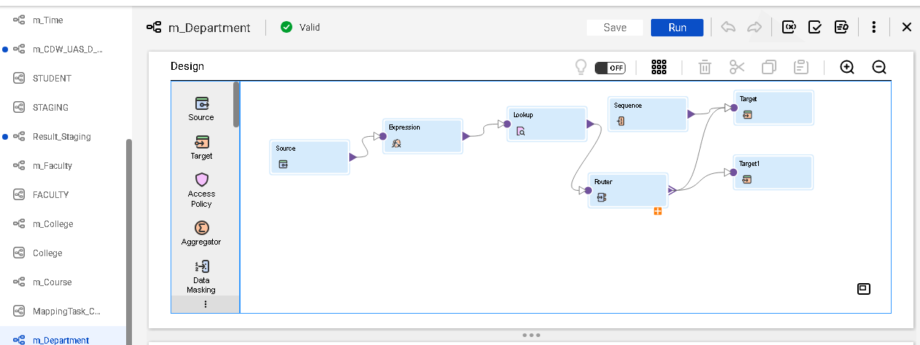
Fig. 16: Department Dimension Mapping

MAPPING TASK
The figure below illustrates the mapping task that executes the mappings created in the Informatica. This mapping task ensures that the data is extracted from the source file, transformed according to the specified business logic and loaded into the target files.

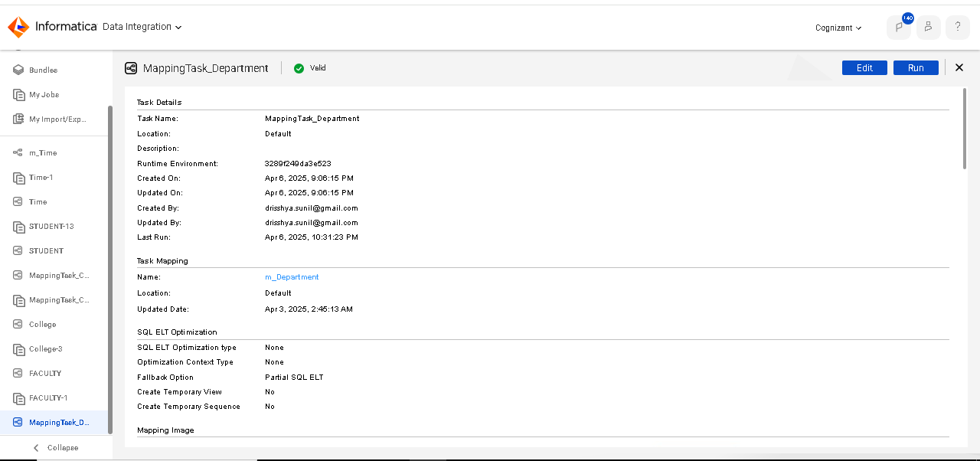
Fig. 17: Department Dimension Mapping Task

TASK DETAILS:
The IICS monitor gives the task status and the number of rows accepted is also verified. The target CDW_UAS_DEPARTMENT files are verified by SQL server database as shown in the figure.

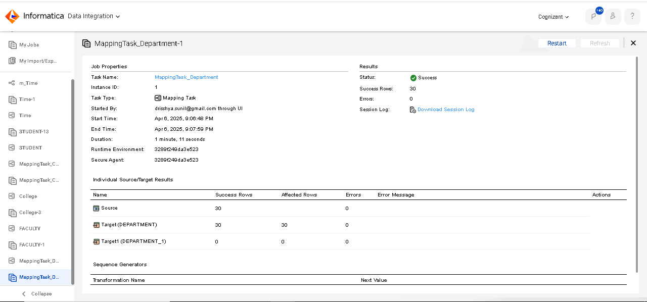
Fig. 18: Department Dimension Monitor

TARGET POST EXECUTION:
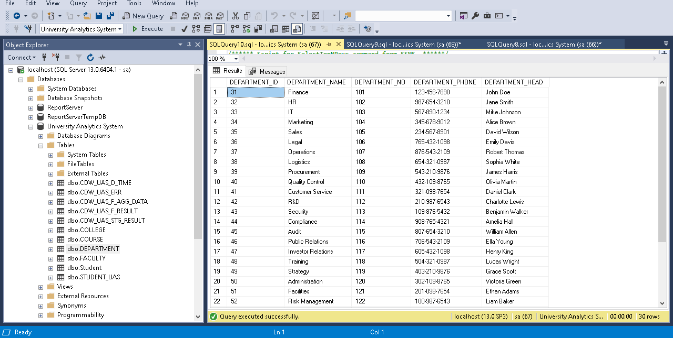
Fig. 19: Department Dimension Target Table

Functional Requirement 5

COURSE
The course dimension table CDW_UAS_D_COURSE is a Type – I SCD which contains all course information. The source file’s name is CDW_UAS_COURSE.txt and it is comma (,) delimited. This table is dependent on the Department table for the Department Id. The department table must contain the respective department information before loading course table. The table is updated/inserted for old/new products respectively on a daily basis and no history is maintained.

SOURCE
As per the requirement, we have been provided with a source comma-separated file. The source file contains field such as a COURSE_CODE, COURSE_NAME, DEPARTMENT_NO and MARK_REQ. Since, the CDW_UAS_D_COURSE table has the field DEPARTMENT_NO which is dependent on the CDW_UAS_D_DEPARTMENT table as source.

SOURCE FILE NAME | DESCRIPTION | SOURCE FILE
CDW_UAS_COURSE.txt (flat file) | This is a comma-separated file. | 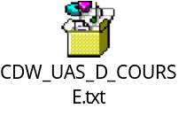
CDW_UAS_D_DEPARTMENT  (SQL server) | This is a SQL server database.
Table 13: CDW_UAS_COURSE Source Description
TARGET
The target table is created in the SQL server database where the attributes are selected from the provided requirements document and imported to the Informatica.

TARGET NAME | DESCRIPTION | TARGET TYPE | TARGET FILE
CDW_UAS_D_COURSE | It is a SCD type 1 table | SQL Server Database | 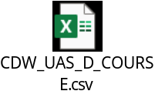
Table 14: CDW_UAS_D_COURSE Target Description

TRANSFORMATIONS:

Column Name | Mapping Logic | Transformation Name | Function Used
COURSE_CODE | Insert for new Course/update the entire record for existing Course( Abort the session if Code is invalid ) | Expression | To_Decimal( )  Abort( )
COURSE_NAME | Trim the trailing spaces and load the data | Expression | Ltrim( )  Rtrim( )
DEPARTMENT_ID | Join with Department table, based on No from Department Table  and load the corresponding Department ID | Lookup
MARK_REQ | Direct move
Table 15: CDW_UAS_D_COURSE Transformations

MAPPING
The figure below illustrates the data flow from the source to the target table, applying the necessary transformations to meet the business requirements.

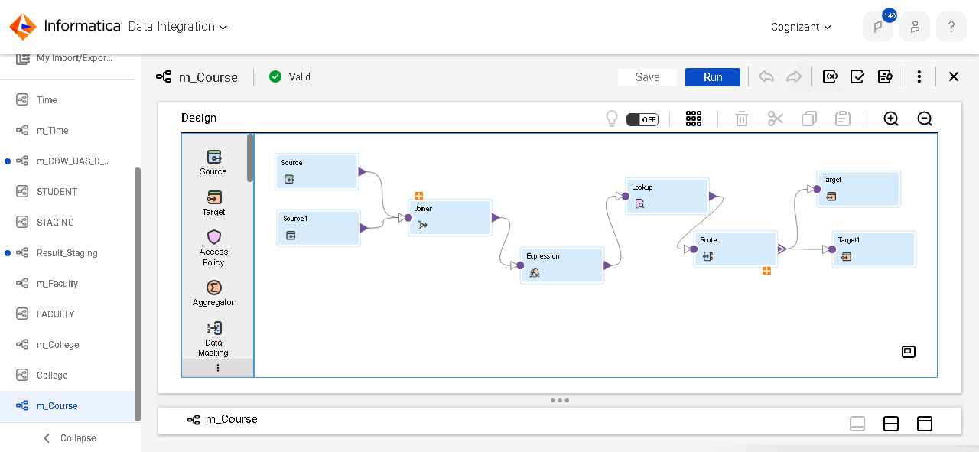
Fig. 20: Course Dimension Mapping

MAPPING TASK
The figure below illustrates the mapping task that executes the mappings created in the Informatica. This mapping task ensures that the data is extracted from the source files, transformed according to the specified business logic and loaded into the target tables.

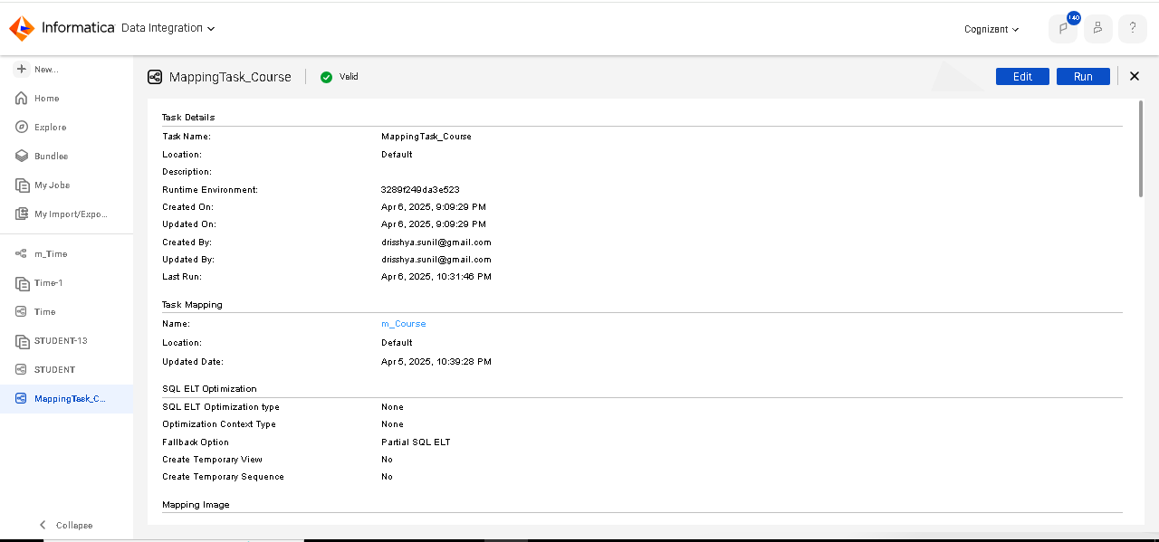
Fig. 21: Course Dimension Mapping Task

MONITOR DETAILS:
The monitor gives the task status, and the number of rows accepted is also verified. The data IN the target file CDW_UAS_D_COURSE is verified in the SQL server database as shown in the figure.

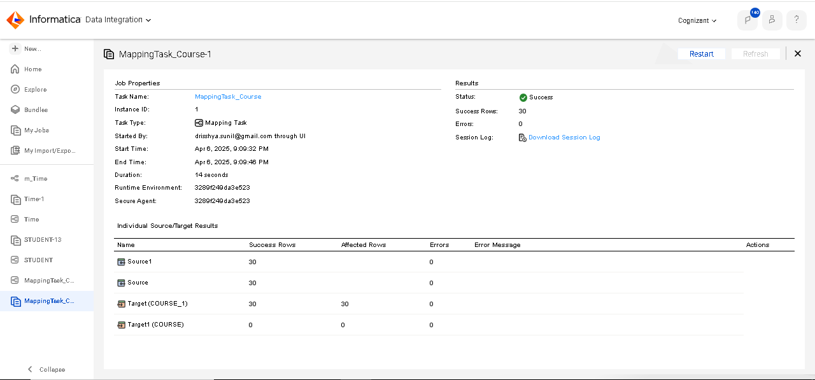
Fig. 22: Course Dimension Monitor

TARGET POST EXECUTION:
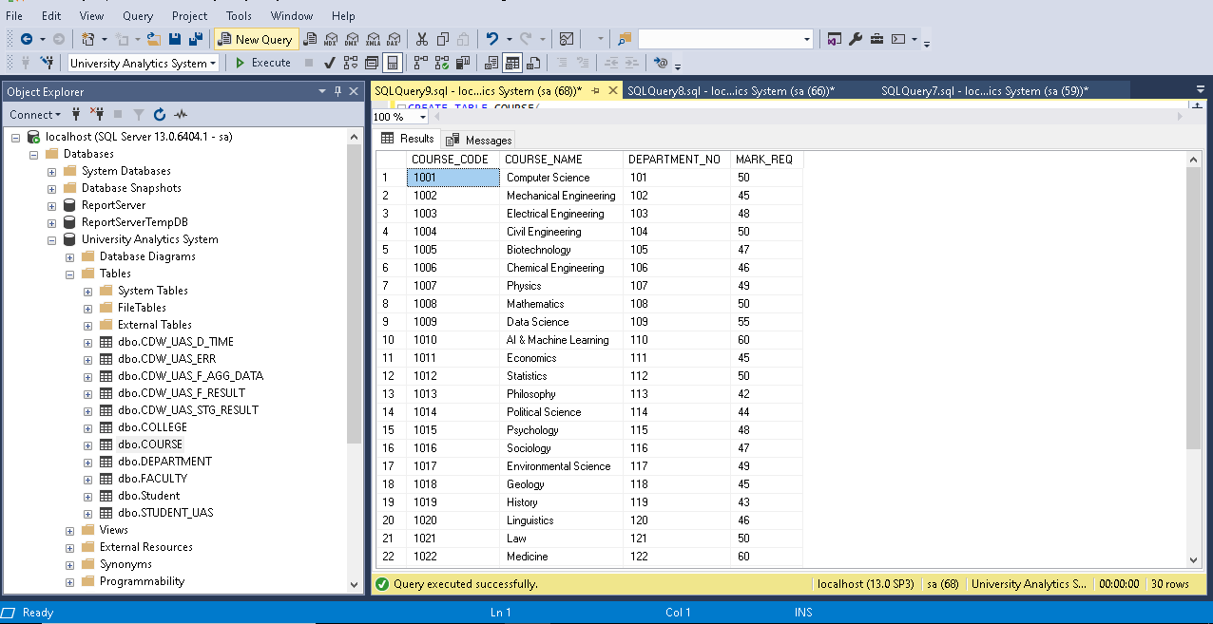
Fig. 23: Course Dimension Target Table

Functional Requirement 6

TIME
The Time dimension table CDW_UAS_D_TIME is a static table which contains the time key and other relevant information. This table is loaded once in a year from the source file CDW_UAS_D_TIME.txt which is fixed width file.

SOURCE
As per the requirement, we have been provided with a source comma-separated file. The source file contains field TIME_KEY.
SOURCE FILE NAME | DESCRIPTION | SOURCE FILE
CDW_UAS_D_TIME.txt (fixed width file) | This is a fixed width file | 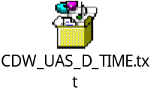
Table 16: CDW_UAS_TIME Source Description
TARGET
The target table is created in the SQL server database where the attributes are selected from the provided requirements document and imported to the Informatica.

TARGET NAME | DESCRIPTION | TARGET TYPE | TARGET FILE
CDW_UAS_D_TIME | Static Dimension | SQL Server Database | 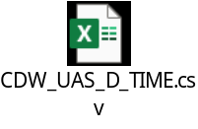
Table 17: CDW_UAS_D_TIME Target Description

TRANSFORMATIONS:

COLUMN NAME | MAPPING LOGIC | TRANSFORMATION  NAME | FUNCTION USED
DAY | Substring from TIMEKEY | Expression | SUBSTR( )  TO_DECIMAL( )
MONTH | Substring from TIMEKEY | Expression | SUBSTR( )  TO_DECIMAL( )
YEAR | Substring from TIMEKEY | Expression | SUBSTR( )  TO_DECIMAL( )
QUARTER | Substring from TIMEKEY | Expression | SUBSTR( )
Table 18: CDW_UAS_D_TIME Transformations
MAPPING
The figure below illustrates the data flow from the source to the target table, applying the necessary transformations to meet the business requirements.

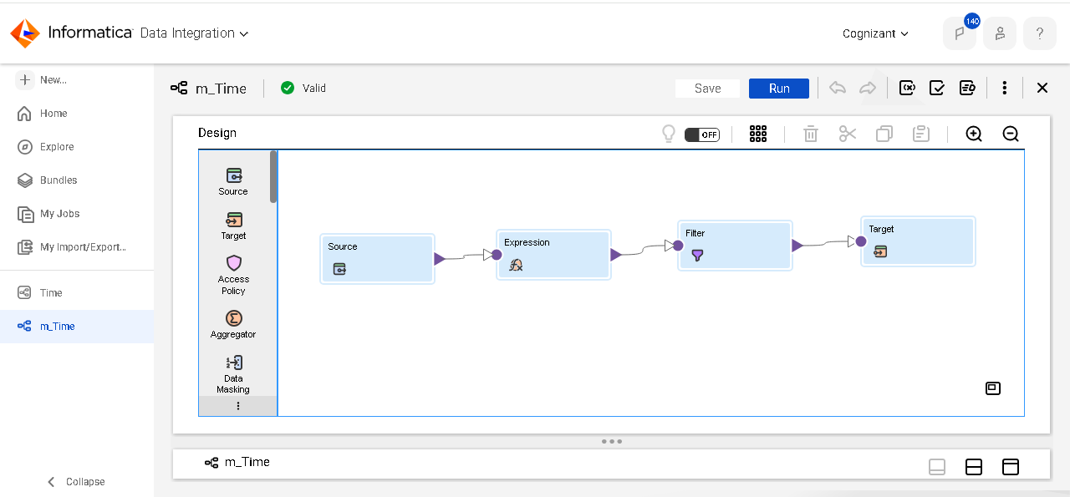
Fig. 24: Time Dimension Mapping
MAPPING TASK
The figure below illustrates the mapping task that executes the mappings created in the Informatica. This mapping task ensures that the data is extracted from the source files, transformed according to the specified business logic and loaded into the target tables.

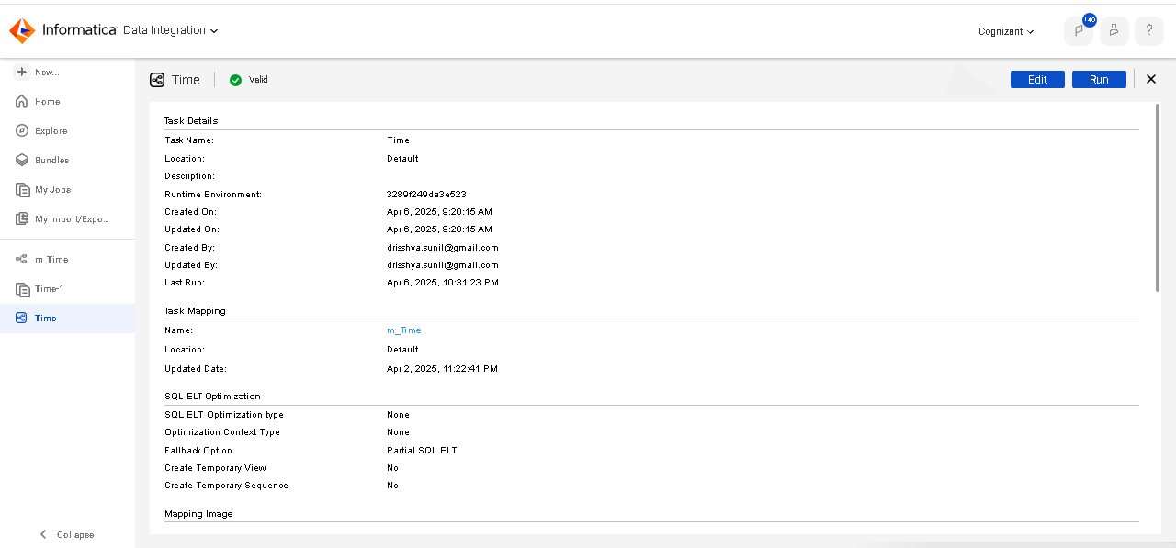
Fig. 25: Time Dimension Mapping Task

MONITOR DETAILS:
The monitor gives the task status, and the number of rows accepted is also verified. The data IN the target file CDW_UAS_D_TIME is verified in the SQL server database as shown in the figure.

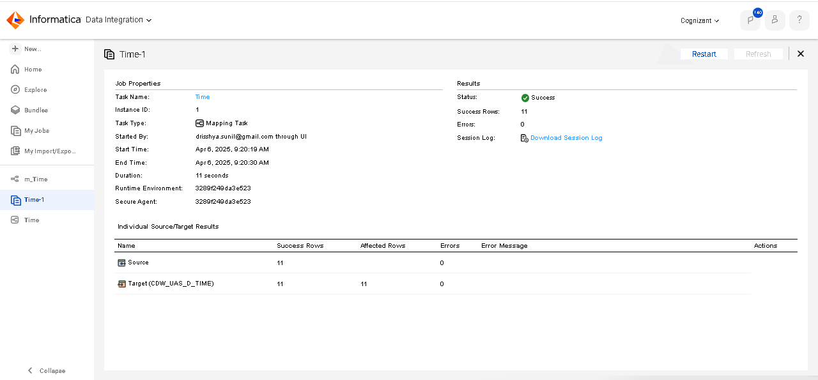
Fig. 26: Time Dimension Monitor
TARGET POST EXECUTION:
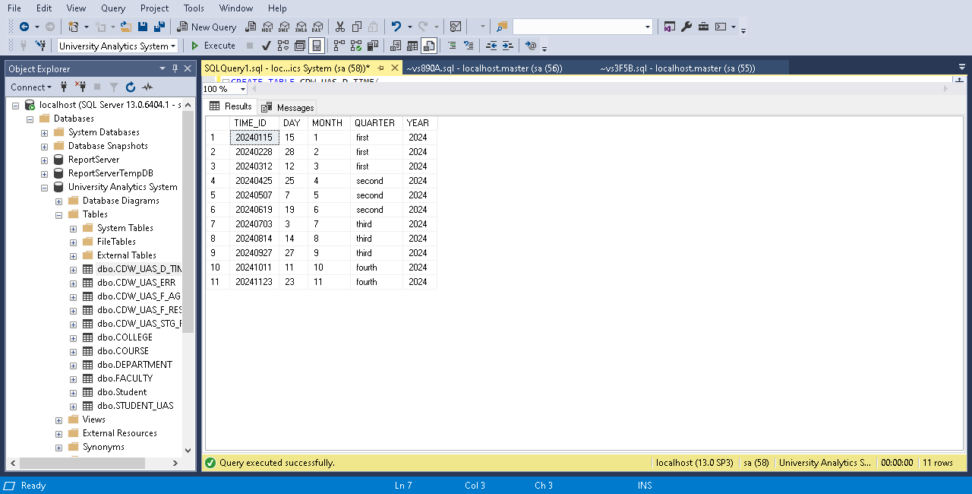
Fig. 27: Time Dimension Target Table

Functional Requirement 7

RESULT STAGING
The results staging table CDW_UAS_D_STG_RESULT receives the results data from the different evaluation centers (Two delimited & one fixed width) CDW_UAS_F_RESULTS_BR_XX.txt and the delimiter used is comma. The information from different files is standardized in the staging table. This table is refreshed every day. The data is loaded with all related dimension information from the respective dimension tables in the warehouse. Records containing invalid information will be sent to the CDW_UAS_ERR error table. The two delimited files are joined before loading in to the staging area.

SOURCE
As per the requirement, we have been provided with a source comma-separated file. The source file contains field TIMEKEY, Student_Roll, DEPARTMENT_No, COLLEGE_NAME, COLLEGE_NAME, COURSE_NAME, COURSE_NAME, FACULTY_NAME, RESULT_MARKS and RESULT_MARKS.

SOURCE FILE NAME | DESCRIPTION | SOURCE FILE
CDW_UAS_D_RESULT_CL_01.txt | This is a flat file delimited with comma. | 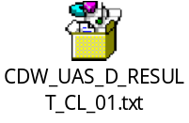
CDW_UAS_D_RESULT_CL_02.txt | This is a flat file delimited with comma. | 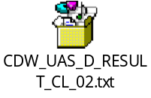
CDW_UAS_F_RESULT_CL_01.txt | This is a fixed width file | 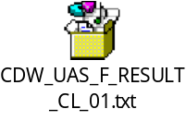
Table 19: Result staging Source Description

TARGET
The target table is created in the SQL server database where the attributes are selected from the provided requirements document and imported to the Informatica.

TARGET NAME | DESCRIPTION | TARGET TYPE | TARGET FILE
CDW_UAS_D_ STG_RESULT | It is a Staging table | SQL Server Database | 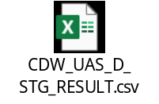
CDW_UAS_ERR | It is a table containing errors while staging | SQL  Server  Database | 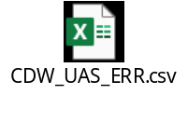
Table 20: Result staging Target Description

TRANSFORMATIONS:

COLUMN NAME | MAPPING LOGIC | TRANSFORMATION  NAME | FUNCTION USED
CDW_P_RESULT_DSET_KEY | Surrogate key of target table using sequence generator | Sequence generator | NEXTVAL( )
RESULT_F_PERIOD_KEY_D | Lookup upon the target CDW_UAS_D_TIME using TIMEKEY | Lookup
RESULT_F_PERIOD_KEY_M | Lookup upon the target CDW_UAS_D_TIME using TIMEKEY | Lookup
RESULT_F_PERIOD_KEY_Y | Lookup upon the target CDW_UAS_D_TIME using TIMEKEY | Lookup
RESULT_F_Student_KEY | Surrogate key of the Student dim table | Lookup
RESULT_F_DEPARTMENT_KEY | Surrogate key of the Department dim table | Lookup
RESULT_F_COLLEGE_CODE | Look up College Code using College name from the College Dimension Table | Lookup
RESULT_F_COLLEGE_NAME | Direct move
RESULT_F_COURSE_CODE | Look up Course Code using Course Name from the Course Dimension Table | Lookup
RESULT_F_COURSE_NAME | Direct move
RESULT_F_FACULTY_NO | Look up Faculty Code using Faculty Name from the Faculty Dimension Table | Lookup
RESULT_MARKS | Direct move from the file/check for decimal values | Source transformation
RESULT_GRADE | Need to be calculated from the Course table data (If the Result Marks is greater than the Marks Required then PASS else FAIL). | Expression | IIF( )
CREATED_DATE | SYSDATE | Expression
CREATED_BY | Workflow name | Expression | '$CurrentTaskName'
ERROR_CODE | Generate the Error code based on the error. | Expression | IIF( )
ERR_MSG | Decode the Error code and set a relavent message | Expression | IIF( )
ERR_COLUMN_NM | Load the name of the column in which has error | Expression | IIF( )
Table 21: Result staging Transformations
MAPPING
The figure below illustrates the data flow from the source to the target table, applying the necessary transformations to meet the business requirements.
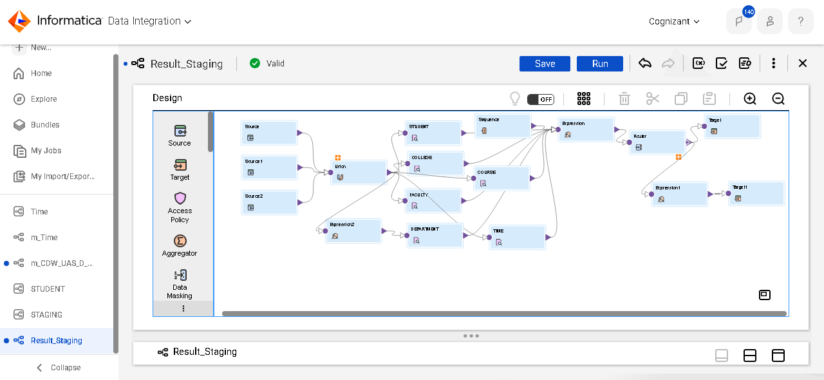
Fig. 28: Result Staging Mapping

MAPPING TASK
The figure below illustrates the mapping task that executes the mappings created in the Informatica. This mapping task ensures that the data is extracted from the source files, transformed according to the specified business logic and loaded into the target table and errors occurred while joining to error table.
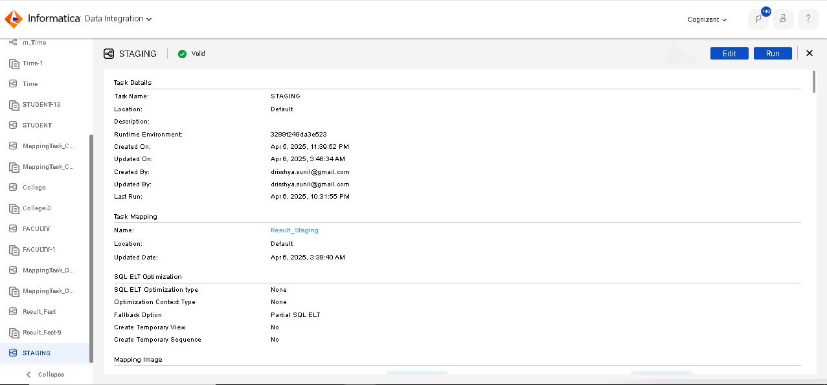
Fig. 29: Result Staging Mapping Task
MONITOR DETAILS:
The monitor gives the task status, and the number of rows accepted is also verified. The data IN the target file CDW_UAS_STG_RESULT is verified in the SQL server database and error file to CDW_UAS_ERR is verified in SQL server database as shown in the figure.

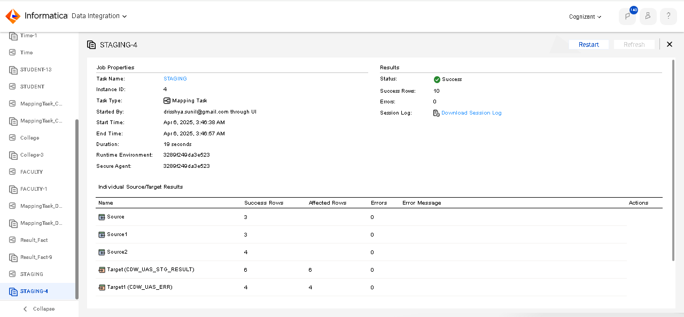
Fig. 30: Result Staging Monitor

TARGET POST EXECUTION:

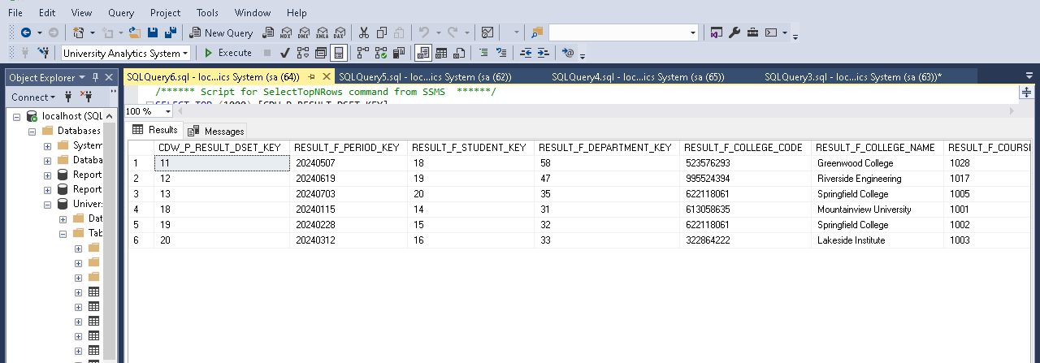
Fig. 31: Result Staging Target Table
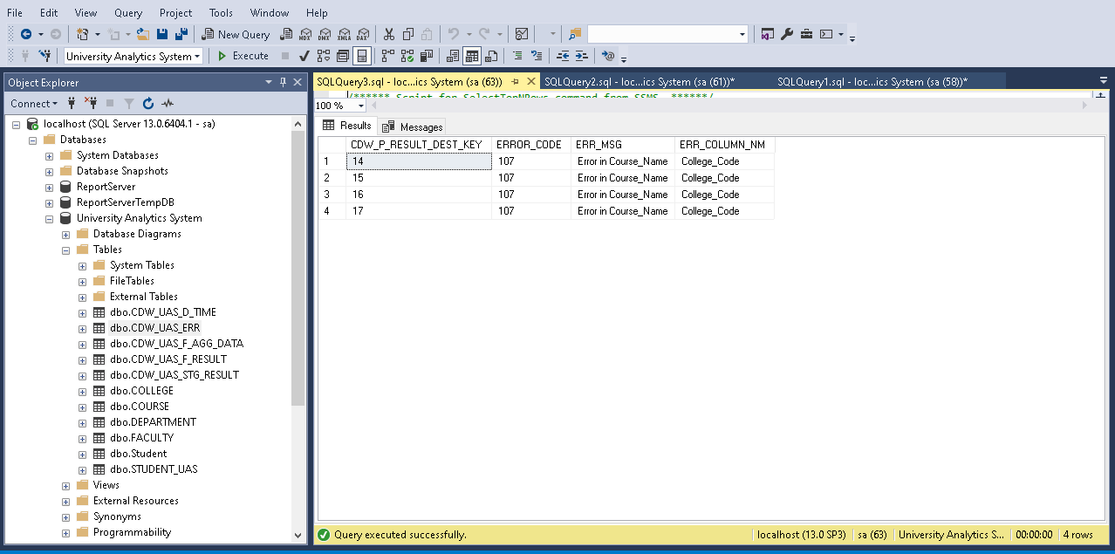
Fig. 32: Staging Error Target Table

Functional Requirement 8

RESULT FACT
The results fact table CDW_UAS_F_RESULT contains all the transactions loaded from the staging table CDW_UAS_STG_RESULTS. This table is loaded only after the staging table has been loaded completely from the transaction files arriving from all the different centers.

SOURCE
As per the requirement, we have been provided with a source database file. The source file contains field CDW_P_RESULT_DSET_KEY, RESULT_F_PERIOD_KEY, RESULT_F_STUDENT_KEY, etc.

SOURCE FILE NAME | DESCRIPTION | SOURCE FILE
CDW_UAS_STG_RESULTS (database) | This is a SQL server database | 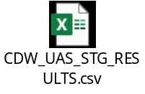
Table 22: Result Fact Source Description
TARGET
The target table is created in the SQL server database where the attributes are selected from the provided requirements document and imported to the Informatica.

TARGET NAME | DESCRIPTION | TARGET TYPE | TARGET FILE
CDW_UAS_F_RESULT | It is a Fact Table | SQL Server Database | 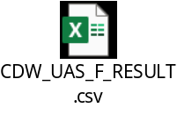
Table 23: Result Fact Target Description

TRANSFORMATIONS:

COLUMN NAME | MAPPING LOGIC | TRANSFORMATION  NAME | FUNCTION USED
CDW_XYZ_F_RESULT_  DSET_KEY | Direct Move
RESULT_F_PERIOD_KEY | Direct Move (Convert to date datatype) | Expression | To_date( )  To_char( )
RESULT_F_STUDENT_KEY | Direct Move
RESULT_F_DEPARTMENT  _KEY | Direct Move
RESULT_F_COLLEGE_CODE | Direct Move
RESULT_F_COLLEGE_NAME | Direct Move
RESULT_F_COURSE_CODE | Direct Move
RESULT_F_COURSE_NAME | Direct Move
RESULT_MARKS | Direct Move
RESULT_GRADE | Direct Move
CREATED_DATE | Direct Move
CREATED_BY | Direct Move
Table 24: Result Fact Transformations

MAPPING
The figure below illustrates the data flow from the source to the target table, applying the necessary transformations to meet the business requirements.

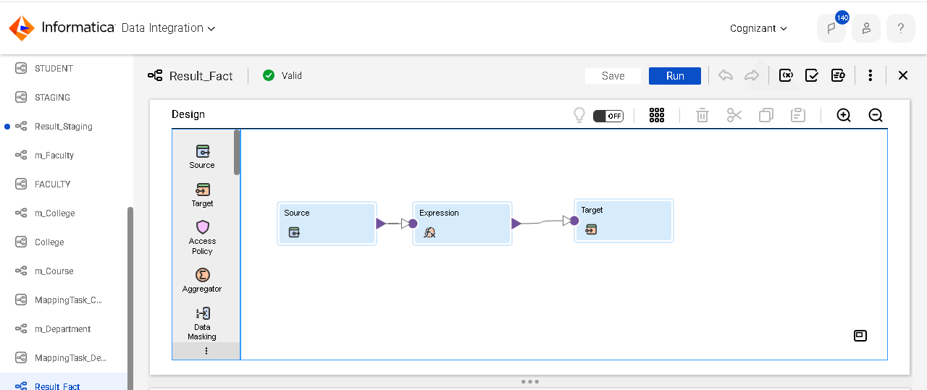
Fig. 33: Result Fact Mapping

MAPPING TASK
The figure below illustrates the mapping task that executes the mappings created in the Informatica. This mapping task ensures that the data is extracted from the source files, transformed according to the specified business logic and loaded into the target tables.
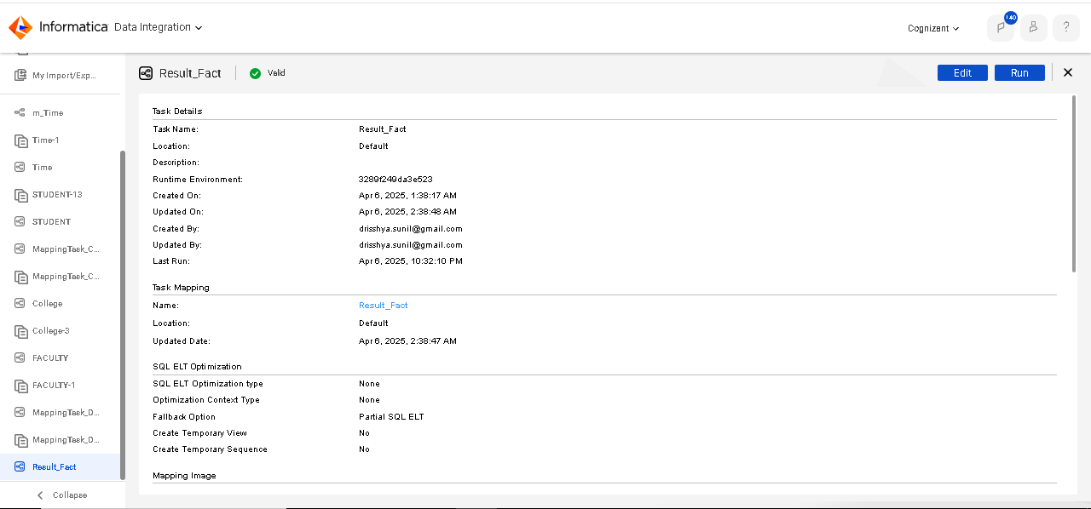
Fig. 34: Result Fact Mapping Task

MONITOR DETAILS:
The monitor gives the task status, and the number of rows accepted is also verified. The data IN the target file CDW_UAS_D_RESULT is verified in the SQL server database as shown in the figure.

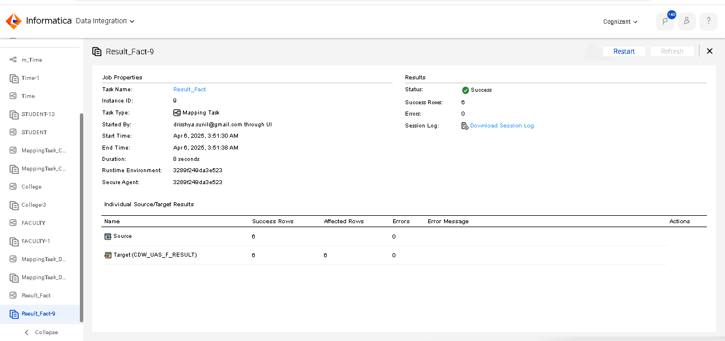
Fig. 35: Result Fact Monitor

TARGET POST EXECUTION:

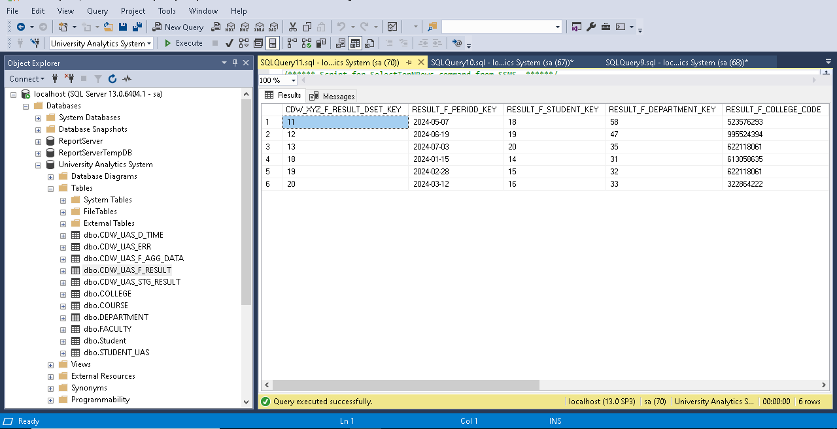
Fig. 36: Result Fact Target Table

Functional Requirement 9

RESULT AGGREGATE
The Sales Aggregate table CDW_UAS_F_AGG_DATA pulls data from the Results fact table CDW_UAS_F_RESULTS. The table is aggregated by college_code & course_code for the current month.

SOURCE
As per the requirement, we have been provided with a source database file. The source file contains field RESULT_F_COLLEGE_CODE, RESULT_F_COLLEGE_NAME, RESULT_F_COURSE_CODE, RESULT_F_COURSE_NAME, RESULT_GRADE and RESULT_MARKS.

SOURCE FILE NAME | DESCRIPTION | SOURCE FILE
CDW_UAS_D_RESULT (database) | This is a SQL server database | 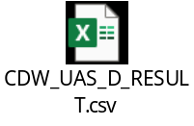
Table 25: Result Aggregate Source Description

TARGET
The target table is created in the SQL server database where the attributes are selected from the provided requirements document and imported to the Informatica.

TARGET NAME | DESCRIPTION | TARGET TYPE | TARGET FILE
CDW_UAS_F_AGG_DATA | It is an aggregate table | SQL Server Database | 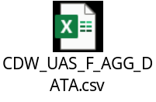
Table 26: Result Aggregate Target Description

TRANSFORMATIONS:

COLUMN NAME | MAPPING LOGIC | TRANSFORMATION  NAME | FUNCTION USED
CDW_RESULT_AGG_  DSET_KEY | Surrogate key generation | Sequence generator
COLLEGE_CODE | College code for the current reporting period sold in each College. | Aggregator | GROUP BY
COLLEGE_NAME | College name for the corresponding College. | Aggregator | GROUP BY
COURSE_CODE | Course code for the current reporting period evaluated in each College. | Aggregator | GROUP BY
COURSE_NAME | Course name for the corresponding Course code. | Aggregator | GROUP BY
TOTAL PASS | Count of the total students passes in a particular Course evaluated in each College for the current reporting period. | Aggregator | Count( )  IIF( )
MAXIMUM_MARK | Maximum mark scored in a particular Course in each college for the current reporting period. | Aggregator | Max( )
CREATED_DATE | SYSDATE | Aggregator | SYSDATE
Table 27: Result Aggregate Transformations

MAPPING
The figure below illustrates the data flow from the source to the target table, applying the necessary transformations to meet the business requirements.

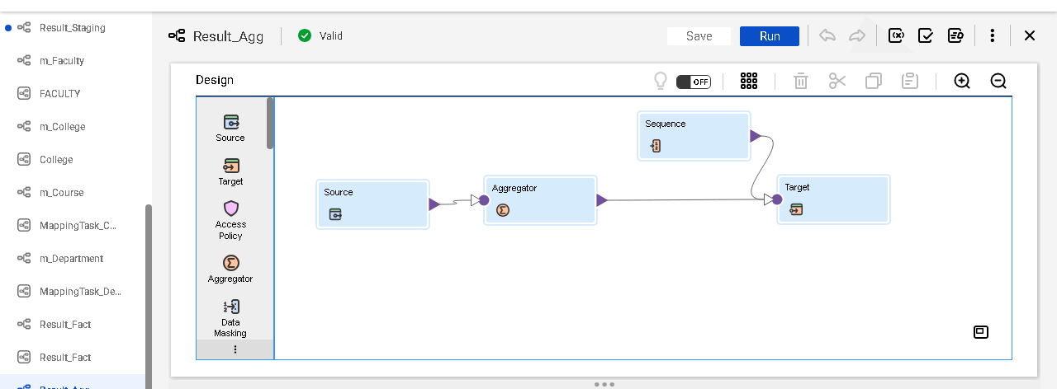
Fig. 37: Result Aggregate Mapping

MAPPING TASK
The figure below illustrates the mapping task that executes the mappings created in the Informatica. This mapping task ensures that the data is extracted from the source files, transformed according to the specified business logic and loaded into the target tables.
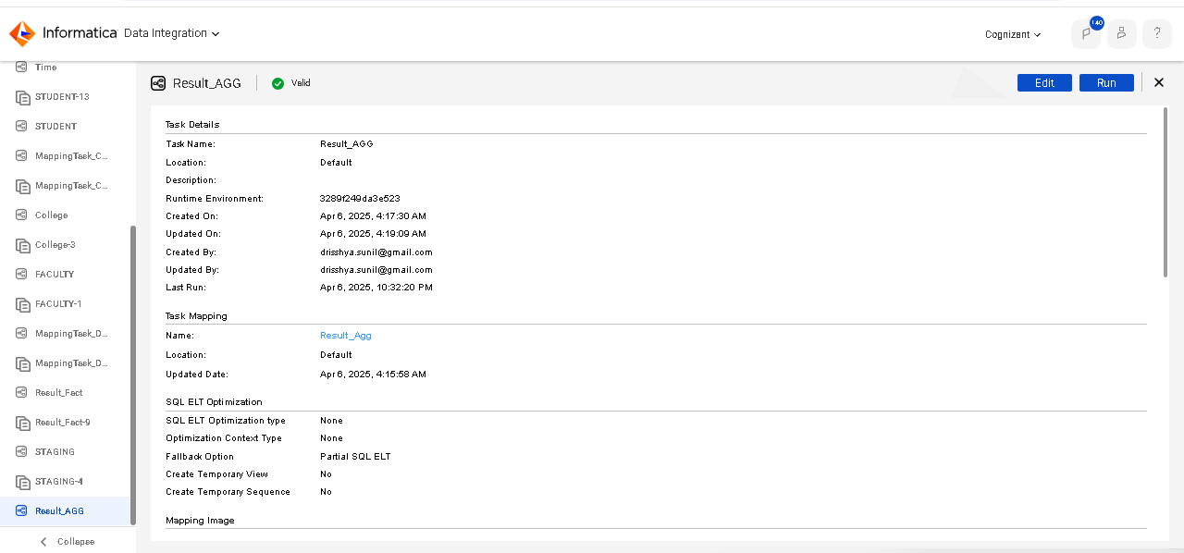
Fig. 38: Result Aggregate Mapping Task

MONITOR DETAILS:
The monitor gives the task status, and the number of rows accepted is also verified. The data IN the target file CDW_UAS_F_AGG_DATA is verified in the SQL server database as shown in the figure.

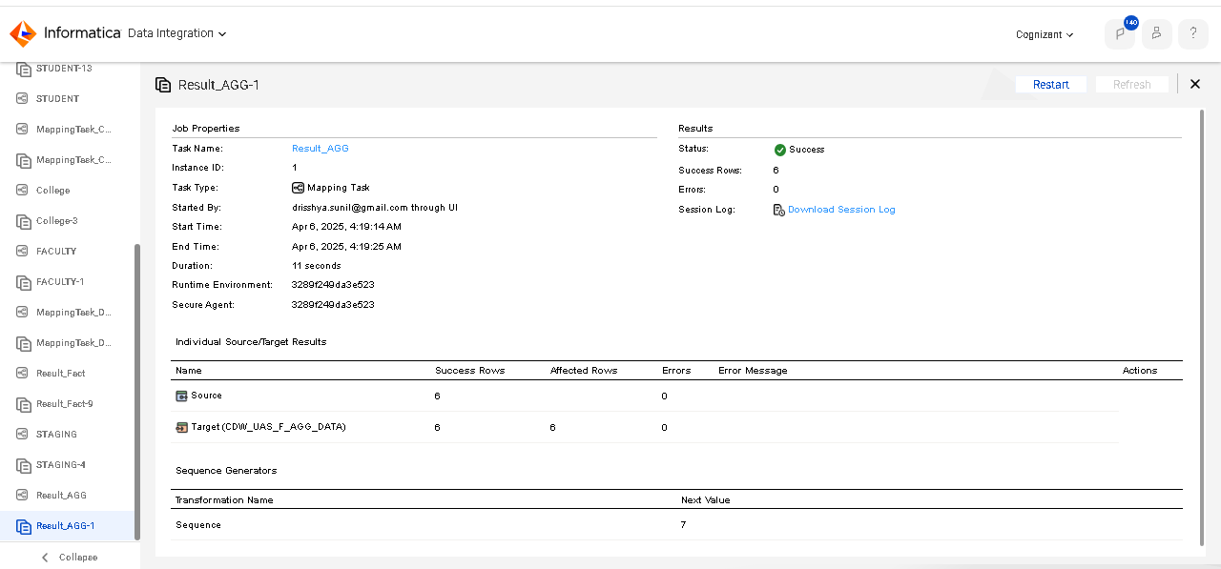
Fig. 39: Result Aggregate Monitor

TARGET POST EXECUTION:

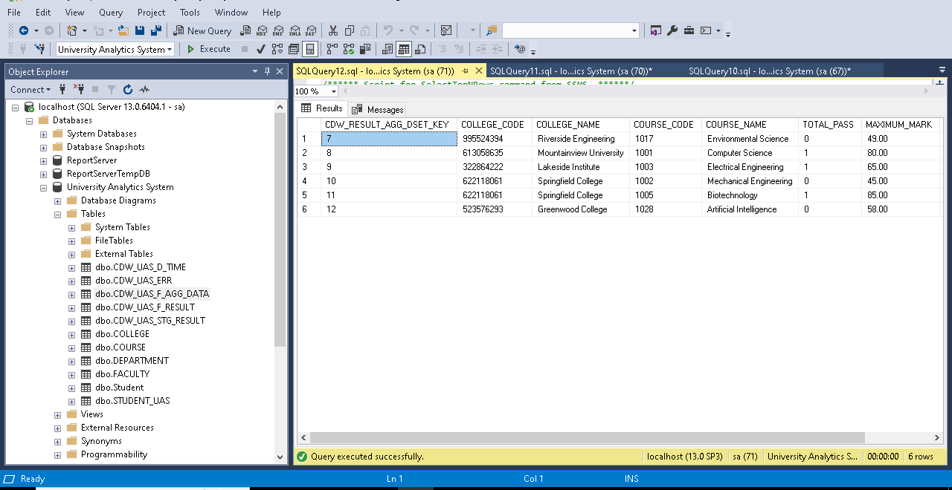
Fig. 40: Result Aggregate Target Table

Integrated Taskflow

The project incorporates a comprehensive and streamlined task flow in Informatica Intelligent Cloud Services (ICS) to unify and automate the execution of all mapping tasks. Each dimension Student, College, Department, Course, Time, and Faculty-is managed through its dedicated mapping task, ensuring modularity and data accuracy. These tasks are cohesively integrated into a single task flow, facilitating seamless orchestration of the entire ETL pipeline.
The staging results table acts as an intermediary, consolidating data from all dimensions to ensure a unified view. This staging layer serves as the foundation for the Result Fact Table, which further feeds into the Result Aggregation Table, enabling multi-level data analysis. The task flow is equipped with scheduling mechanisms, allowing the mappings to run automatically based on predefined triggers, thereby eliminating the need for manual intervention. By integrating all components into a unified workflow, the task flow ensures consistency, reduces error rates, and enhances efficiency in data processing. This design not only supports the current business needs but also provides a scalable framework for future enhancements.
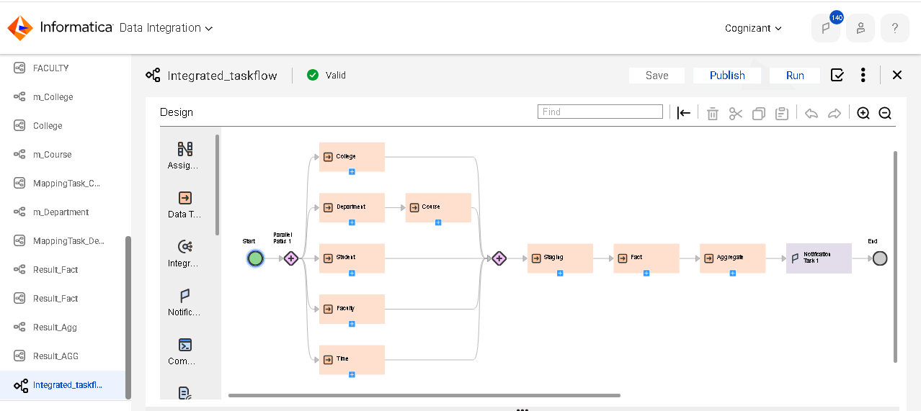
Fig. 41: Integrated Taskflow

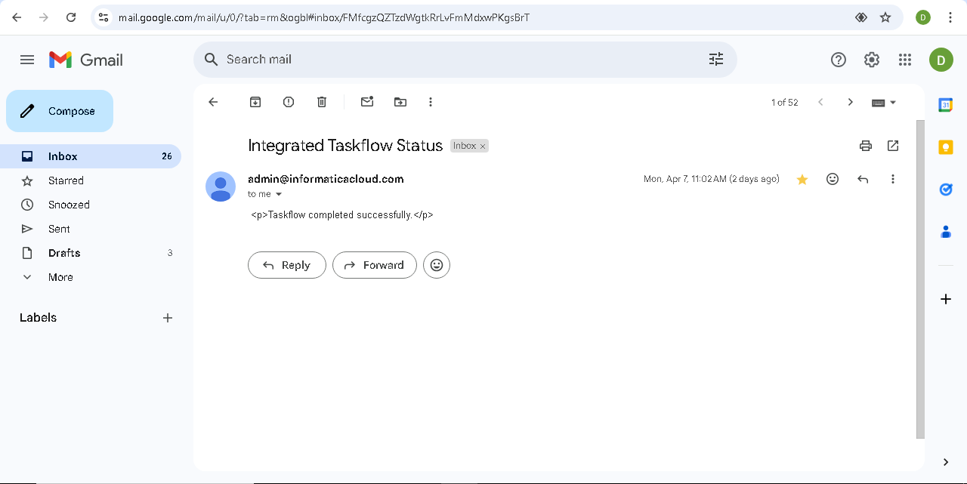
Fig. 42: Integrated Taskflow Notification

Design Constraints

CONSTRAINT | SUCCESS | IMPLEMENTATION
Student table should get loaded only when a valid No exists in the source file. | Yes | Same column name (No) having matching values in both source and target tables.
An item record getting loaded into the fact table should have a corresponding entry in the item dimension table. | Yes | COURSE_CODE loaded to the Fact Table.
A customer record getting loaded into the fact table should have a corresponding entry in the customer dimension table. | Yes | DEPARTMENT_ID loaded to the Fact Table.
The ETL data flow schedule should accommodate the order of dimension table loading before the fact table load. | Yes | Scheduled the workflows of dimensions in parallel, loading the fact table only when all dimensions are succeeded.
The customer-item fact table should calculate the total price based on the number of items and item price. | Yes | Implemented calculation logic in the transformation step.
The phone number format should be standardized to xxx-xxx-xxxx. | Yes | Applied transformation logic to format phone numbers.
The address fields should be concatenated with a comma separator. | Yes | Used concatenation logic in the transformation step.
The names should be converted to title case and lower case as specified. | Yes | Applied transformation logic using InitCap() and Lower() functions.
The ROLL NO should be validated and converted to a number. | Yes | Applied validation and conversion logic in the transformation step.
The data load process should abort if any critical validation fails. | Yes | Implemented validation checks and abort logic in the ETL process.
Table 28: Design Constraints

Conclusion and Future Scope
This project successfully implements a robust data integration and warehousing solution using Informatica Intelligent Cloud Services (IICS). By creating distinct mapping tasks for each dimensional table and seamlessly integrating them into a unified task flow, the architecture guarantees scalability, accuracy, and efficient data management. Employing SCD-2 for the Student table ensures effective historical data tracking, while SCD-1 for other tables provides timely updates with reduced complexity. The staging results layer, Result Fact Table, and Result Aggregation Table collaborate to deliver thorough insights and analytics-ready data.

The future scope of the project includes:
- Enhanced Automation: Implement real-time data integration and automation pipelines to reduce latency and improve operational efficiency.
- Advanced Analytics: Integrate predictive analytics and machine learning models to derive deeper insights and support decision-making.
- Scalability Expansion: Optimize the architecture to handle larger datasets, increasing system capacity to accommodate growing organizational needs.
- Multi-Cloud Integration: Extend support to integrate data from multiple cloud platforms for broader data consolidation.
- Data Quality Enhancements: Develop robust data cleansing and quality-check mechanisms to ensure the accuracy and reliability of the data.

